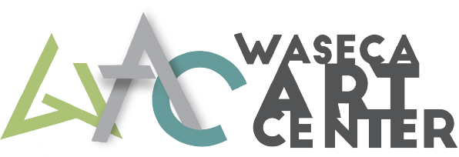
Address: 200 N State St, Waseca MN 56093
Phone: 507.835.1701
Email: info@wasecaartscouncil.org

Waseca Art Center - Class Proposal Form
Please fill out the information below (Read through entire application before beginning):

Title of the Class:
Instructor(s) Name:
Would you like an assistant on hand? Yes No
Anticipated Location: WAC Basement, WAC Auditorium, Other (ex. Trowbridge Park):
Student Ages/Grades (ex. K-3, Adults, Jr. High):
Min # of Students: Max # of Students:
Class Type:
Seminar Craft Project Art Enrichment Other (Please Specify):
Prefered Class Days (specify if this is a one day, or recurring class):
Tuesday Wednesday Thursday Friday Saturday
Prefered Class Times:
Morning Afternoon Evening
# of Sessions: Duration of Class (ex. 1.5 hours):
How many days total will this specific class run?
Expected Prep time, set-up/tear Down, & clean up time:
Please Provide a Brief Class Description:

Anticipated Supply Fees: Please provide a list of materials and whether they will be provided or if attendees should bring their own (WAC will reimburse instructors up to $20 for materials - receipts and approval needed):

Instructor’s Education, Certifications, and Qualifications:

Have you taught with WAC before? Yes No
Have you taught this particular class previously? Yes No
If yes, what enrollment did you have and did you feel the program was successful?

Please include images, if applicable, of the work members in your class might expect to produce. Photos pertaining to the class are encouraged for promotional purposes. (Attach files as separate document when emailing - Thank you!)

Will you be promoting your class through social media?

Instructor Contact Information:
Name:
Address:
City: Sate: Zip Code:
Phone:
Email:

The Waseca Art Center is a non profit organization, we pay instructors $30/hr in addition to minimal prep time for class instruction and demonstrations. Please let us know if you require additional compensation.

Please return your proposal by email to info@wasecaartscouncil.org or by dropping it off at the Waseca Art Center located at 200 N State St, Waseca MN 56093|Check our website for current hours.
Thank you for your interest enhancing art in our community and teaching with the Waseca Art Center.

